Assessment Task

# Background and Preliminary research

Car dealer software, also known as dealership management systems (DMS), includes products that assist in the operations of automobile retailers. These products can assist with both front- and back-office tasks and may provide tools for inventory, cost calculation, financing, and authorization—for both cars and customers (e.g., credit reports, accident history, etc.). Car dealer software tools can also offer features for preparing, tracking, and storing warranty information, sales contracts, auto repairs, appraisals, and recurring e-payments. Car dealer solutions may integrate with or offer features of billing software, inventory management software, website builder software, or CRM software. Car dealership CRM software adapts all of these instruments for use by car dealerships and provides some supplementary functions, such as lease and sales management, that are peculiar to car dealerships.

Depending on the type of deployment used, the global DMS market is subdivided into two types: on-premises and web-based dealer management software. [Cloud-based dealer management systems](https://www.ergonized.com/custom-crm-software-development/) are at their peak nowadays. The reason behind this is pretty simple: cloud software is cheaper than on-premises software. Besides, the solid network infrastructure in developed countries also supports the adoption of cloud software. Various companies plan to invest heavily in up-to-date software to quickly migrate to modern platforms integrated with top-notch functions. The use of cloud software has quickly increased, mostly due to the benefits that cloud technology offers to enterprises. These advantages include easy support and maintenance, fast setup and deployment, easy upgradeability, and wide availability. With the growing demand for web-based auto dealer software, most dealer management system vendors now offer cloud-based software.

## Car Dealer Software

An automotive dealership software is needed to automate car dealers’ routine processes and retails. Such software, well-known as Dealership Management System (DMS) software, offers plenty of opportunities.

### There are two main types of car dealer solutions:

* **Auto dealer software web-based**. Web-based software allows people to interact with a remote server through a browser.
* **Cloud-based software**. It is a program that runs over the internet, the components of which are stored on the network, and some (or all) of the processes are executed in the cloud.

## Features of Car Dealer Software

### Inventory

It is possible to know what is accessible in a batch at any point with the help of the inventory control feature.

### Contact Database

One of the auto dealer contact management software's tasks consists of providing a comfortable database to preserve clients’ information and concerning documentation, such as various appointments and repair history.

### Accounting

A robust and sophisticated automotive accounting software helps you closely monitor all points of your dealership, including transactions, parts and service paybills, and more.

### Payment

Software dealerships offer companies assistance with controlling off-the-shelf challenges, including the payment for various types of products or services, such as professional and recurring utility billings. It easily integrates with accounting software and ERP or CRM solutions that store information about clients and the items or services they have bought.

### Marketing

A quality auto dealer marketing software helps campaign managers create a suitable approach to auto retail for current and potential clients. With such, they can increase customer loyalty by rolling out a rewards and benefits program, leading to loyal customers' returns.

### Sales Automation

With the help of car sales assistant software, you can better understand where your leads are coming from and how they close. This clears up your ROI across channels and allows you to spend your marketing budget more strategically.

### Lease Management

Auto rentals feature various sets of parameters, and therefore, diverse documentation compared to direct sales. That’s why some car dealership CRMs provide a list of particular functions for tracking leases, such as paying and repairs.

### Workflow Automation

Standardization of corporate processes is a key goal of workflow automation. It occurs through a set of to-do lists, calendars, notifications, and templates. For instance, when a task is marked as accomplished, the software can automatically set up the task for the next step in the process. Car sales software may be critical to sales that involve numerous departments of a dealership.

Two types of solutions are required to run a dealership. One is a **Dealer Management System** (DMS) and the other is a **Customer Relationship Management** (CRM) system. The difference between the two is that DMS manages inventory and deals, while CRM manages your customer database.

### Dealer Management System (DMS)

The first type of car dealer software you should know about is DMS. It is a program package that provides car dealers with the instruments they need to manage their enterprises as efficiently as possible. By integrating several parts of the dealership into a single interface, DMS software automotive enables business owners to better control dealership operations and see the whole picture clearly.

### Customer Relationship Management (CRM)

Customer relationship management software is needed for each enterprise, including car dealerships. Such software is created to simplify managing the interactions with existing and prospective buyers. Start by storing all clients’ data in this program. Then, invite your sales team to use the auto dealership management software to record every interaction with each client. Many CRM systems are configured to optimize and automate customer interactions to ensure consistency and continuous engagement. A good CRM stores valuable information about business operations with actionable data and analytics that help drive the business. Top automotive CRM offers all the necessary tools for manufacturers, specialized automotive companies, and dealerships to attract and keep leads and increase sales conversions. Dealership CRM software focuses on providing a unique experience for car buyers and more. CRM software offers numerous features, capabilities, and advantages to entrepreneurs operating in the automotive sector. Car dealership CRM instruments can be used to monitor the performance and efficiency of the salesforce based on actions recorded in the CRM system, such as how many vehicles are sold per month or which brands/models are the best sellers. Moreover, these instruments can forecast and track commissions.

### Cost estimate

### Systems Development methodology

The waterfall method has a proven track record for CRM implementations, especially for projects that aren’t extremely adaptive, have the requirements well documented and a sequential set of plans. A high level of interaction at the beginning is what is required for the digitization of the customer data and inventory along with other tasks, however towards the end not much interaction is present.

However due to strict and rigid nature of the waterfall model, a hybrid between the waterfall and iterative approach like Agile will be adopted. The Agile method is known to be more adaptive with constant testing and QA and is open to changes. Since the delivery methods for the solutions via web platforms is also through mobile devices, constant deliveries of user-verified features allow for project progress tracking and success is obtained because of business objectives that are delivered to a customer. The agile method is also known to be very highly user dependent and hence for a car dealership where there can a variety of tasks in services, purchase, sales and rentals the requirements are constantly evolving and hence can be dealt with continuous interaction with user throughout the project.

Effectively the high-level design will be addressed using the Waterfall development methodology while the low-level design will be addressed with the iterative system development methodology i.e. Agile development methodology.

# New proposed system details

### Vision and Goals

1. Develop a web platform i.e. a responsive website for the Desktop devices and an app for mobile devices.

2. Develop a backend system for storing digitized information of old and new customers. Also create and manage a database of all cars along with their images and specifics like seats, doors etc. The database should also store information of local mechanics for buyers and possible finance options.

3. Develop a front end for sellers to list their cars or contact an in-house dealer to advice the seller on the sale of their car.

4. Develop an analytics system for storing the characteristic customer behaviour on the web platforms for reducing the churn rate and other marketing analytics. The analytic systems would also be able to predictively model and suggest customers cars for their searches that don’t find a match.

Goals:

The goal is digitize the Horizon Motors Ltd. business both to storing information and interacting with old and new customers for purposes of sales, services, purchase and rental with expert advice on all the aforementioned activities and also analytics solutions for marketing analytics and automated customer service (example recommendations and chatbot assistance)

### Identification of Stakeholders

The stakeholders have been identified by the possible categories:

## Users:

* + Horizon Motors Ltd.
* Customers:
  + Customers who have previously been associated/ have dealt with Horizon Motors Ltd. and new customers.
  + Individual customers and Commercial companies looking for contractual car services or renting a car, either on an hourly basis or longer periods of time
  + Buyers looking for buying used or new cars and some looking for the same with easy finance options
  + Sellers looking for selling their used cars and sales advice along with service.
* Software development team
  + Requirements specialists
  + Front-end software developers
  + Back-end software developers
  + Data Scientist and Analytics team
* Development management team
  + IT and business administration managers to interface with the client and development team

### Constraints and assumptions made

### Design Strategy outline

# Project Plan

# Requirements Specification

### Functional requirements

|  |  |
| --- | --- |
| FR1 | Authentication of the user when they try to sign-in |
| FR2 | Verification email sent when the user sign-ups for the first time |
| FR3 | Request for user location |
| FR4 | The Home pages displays buttons Rent, Purchase, Sale, Service |
| FR5 | ‘Rent’ redirects the user to the Car Rental page |
| FR6 | ‘Purchase’ redirect to the purchase page, where the user selects ‘new’ or ‘used’ car |
| FR7 | ‘Price Range’, ‘car’, ‘colour’, ‘make’ computes, filters and display cars |
| FR8 | ‘Sales’ redirects the user to the sales page, giving the options to contact a dealer or post a listing. |
| FR9 | ‘Contact a dealer’ displays a form to fill user details along with the car details. ‘Add picture’ opens a dialog box to add pictures of the car. ‘Price requested’ box allows user to fill the expected sale value of the car. |
| FR10 | ‘Post a listing’ displays a form to fill the details of the car and the |
| FR11 | ‘Service’ redirects the user to book an appointment. A calendar with dates appear. On clicking a date, time slots are selected. |

### Non-functional requirements

|  |  |
| --- | --- |
| NFR1 | Emails should be sent with a latency of no greater than 12 hours. |
| NFR2 | Each request should be processed within 10 seconds. |
| NFR3 | The site should load in 3 seconds when the number of simultaneous users are > 10000 |
| NFR4 | The system must be allowed at all times, Only 2 minutes downtime is allowed, |
| NFR5 | The system should run on any linux system |

### Use Case : Narrative Form

|  |  |
| --- | --- |
| Use Case ID | UC1 |
| Name | Renting a car |
| Priority | Medium |
| Description | 1. The user is presented with a dropdown menu for the following items    1. start date and end date,    2. start time and end time,    3. type of car 2. The user sets the start time and date and end time and date. The end time and date with a minimum of 1 hour from the start time. 3. The user then selects a car of their choice and an approximate cost appears on the screen 4. When all fields are complete the ‘Next’ button gets highlighted 5. The user can click the ‘Next’ which brings them to the confirmation step |
| Primary Actor | Existing Customer |
| Secondary Actor | None |
| Pre-Conditions | Successful signed in |
| Post-Conditions | Car for rent confirmed |

|  |
| --- |
|  |
| Use Case |

# **System** analysis and design

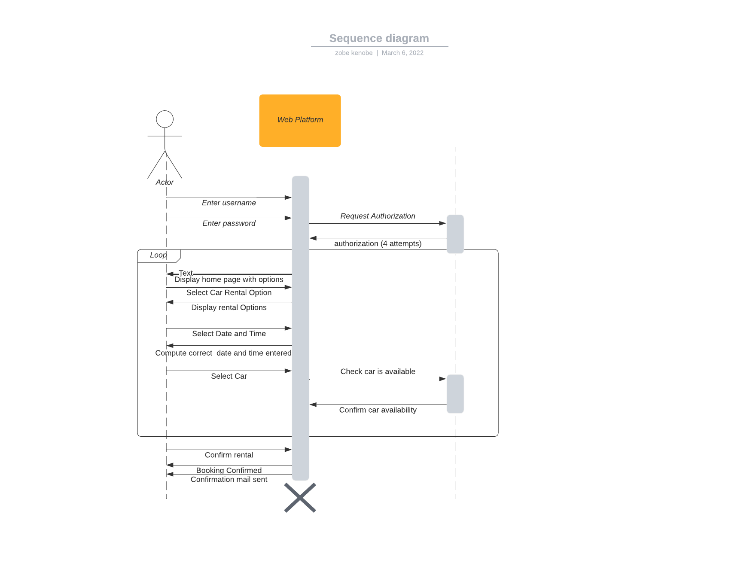

# **System** development/ Implementation

# Conclusion

The auto dealership sector is extremely competitive and since the advent of the lockdown, there have been several auto dealerships that have been seeking to make a web presence and automate several of the in-person tasks. From a business perspective, Horizon Motors Ltd. is face with a two-fold problem first is the digitization of their existing customers and the second is the establishing a web presence and pulling in more customers.

Both are addressed and solved well with the solutions strategy outlined in this report. The existing customers information can be digitized and stored in databases, with all their service related information and contact details securely and safely stored. Secondly, the web presence allows for new customers to be based even outside their operating area i.e. North Dublin when they seek information on selling, purchasing, servicing or renting a car. The in-person contact reduces their staff requirement or rather a redirection of their expertise and focus into other areas of the business. This could also allow them to open another branch and shift their staff there.

Finally with a data driven approach, several processes can be automated. With the advent of time as more data is collected, in the future the customer churn can be monitored and the marketing services could engage with existing customers to make promotional offers etc.

# Bibliography

Lethbridge, T. and Laganiere, R. 2008. Object Orient Software Engineering, 2nd Edition, McGraw Hill.

Roques, Pascal, 2004. UML in Practice, Wiley